# SwabFlush Prefilled Syringes with ICU Medical SwabCaps Consumer-Level Recall - CUSTOMER CARE/SPECIALTY TALK TRACK

# 

**Background Information:** On June 16, 2025, Medline Industries, LP issued a user-level recall of SwabFlush Prefilled Syringes with ICU Medical

SwabCaps NDC # 63807010301. This recall was issued because ICU Medical has issued a recall of their SwabCapTM Disinfecting Cap for Needle-free Connectors, an integrated component of the SwabFlush syringe, after identifying a lot-specific issue where the seal between the foil lid and the plastic container of the SwabCap may be incomplete due to a manufacturing issue. This may result in evaporation of the isopropyl alcohol on the sponge.

This recall affects lot numbers 3144609, 3144857, 3144886, 3144967, 3145090 and 3145186.

If the defect is not identified during setup and a defective SwabCap is used, this may result in a reduced level of disinfection of the luer access valve, potentially resulting in patient infection/sepsis. To date, ICU Medical has received zero (0) reports of serious injury or deaths associated with this issue. Affected SwabFlush Prefilled Syringes with ICU Medical SwabCaps are to be destroyed.

**Please note:** This product is not carried by the CVS Caremark Mail Order Pharmacies.

# Customer Care Talk Track:

** Please ensure to disposition all recall calls to code “**1116**” **

|  |  |  |  |  |  |
| --- | --- | --- | --- | --- | --- |
| **Q#** | **Question** | **Action** | **Answer** | | |
| **1** | **I heard that there is an issue with my SwabFlush Prefilled Syringes with ICU Medical**  **SwabCaps. Can you give me more information?** | Note: Check PeopleSafe to determine if the medication is from Mail or Specialty Pharmacy | If the medication was dispensed from… | Then say… | |
| Mail Order | * Yes, I can. * **Proceed to Q2** | |
| Specialty | While in PeopleSafe, determine the phone number of the dispensing Specialty pharmacy and transfer the call.A: Yes, I can. Please hold while I transfer you to your Specialty Pharmacy. | |
| Customer Care/Specialty Talk Track | | | | | |
| **2** | **Why is there a recall? What is wrong with the product?** |  | On June 16, 2025, Medline Industries, LP issued a user-level recall of SwabFlush Prefilled Syringes with ICU Medical SwabCaps. This recall was issued because ICU Medical has issued a recall of their SwabCap™ Disinfecting Cap for Needle-free Connectors, an integrated component of the SwabFlush syringe, after identifying a lot-specific issue where the seal between the foil lid and the plastic container of the SwabCap™ may be incomplete due to a manufacturing issue.  For more information, call the Medline Recall Department toll-free at 1-866-359-1704 or email [recalls@medline.com](mailto:recalls@medline.com). You may also call the United States Food and Drug Administration (FDA) toll-free at 1‑888‑INFO-FDA (1‑888-463-6332) or visit [www.fda.gov](http://www.fda.gov). | | |
| **3** | **May I return the rest of the SwabFlush Prefilled Syringes with ICU Medical**  **SwabCaps that I have?** | Determine if the patient is affected by this recall | First, let’s determine if you are affected by this recall: | | |
| **If the product was dispensed in…** | | **Then say...** |
| Manufacturer’s Package | | * Check the lot number. The lot number is on the manufacturer’s carton and on the label on the syringe. * If your product is not from one of the affected lot numbers, it is not affected by this recall.   **Please note: This product is not carried by the CVS Caremark Mail Order Pharmacies.** If you received any recalled product from your retail pharmacy, please contact the pharmacy that filled your prescription for more information including return instructions. |
| **4** | **Should I stop using my SwabFlush Prefilled Syringes with ICU Medical**  **SwabCaps?** |  | If the medication was dispensed from… | | Then say… |
| Mail Order | | Please hold while I transfer you to one of our Clinical Counseling Clinicians. |
| Specialty | | Please hold while I transfer you to your Specialty Pharmacy. |
| **5** | **Will I receive credit for the product I return?** |  | Your insurance will be credited for any affected product returned to us. We will replace the affected product with unaffected product. You will not be charged any additional copayments. | | |

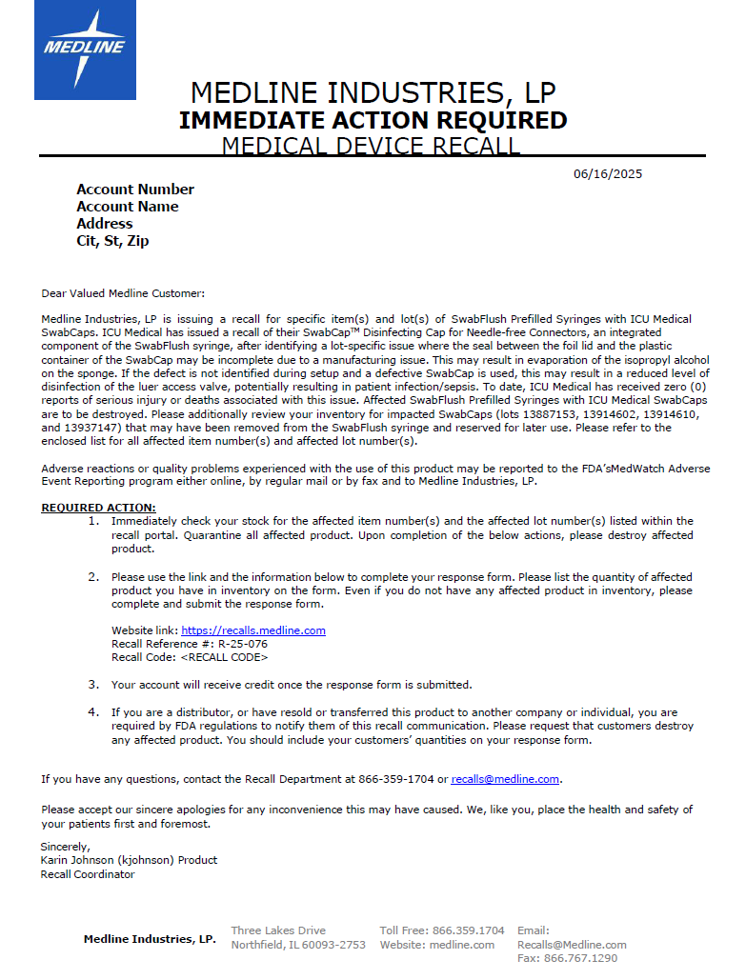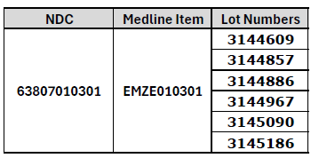

Top of the Document

Not To Be Reproduced Or Disclosed to Others Without Prior Written Approval

**ELECTRONIC DATA = OFFICIAL VERSION / PAPER COPY = INFORMATIONAL ONLY**